Ben Brandhorst
06/07/2019
SDEV 300 6380
Professor Craig Poma
Building Secure Web Applications

Introduction to PHP

Overview of Both Tables
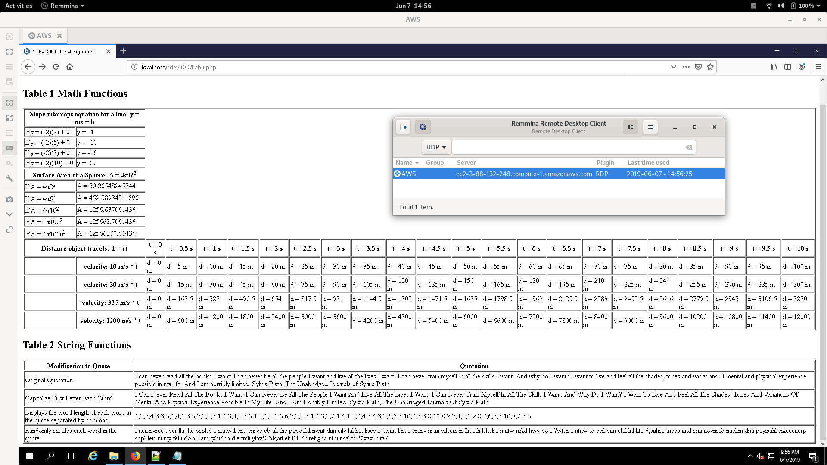

Zoomed In Shot of First Table
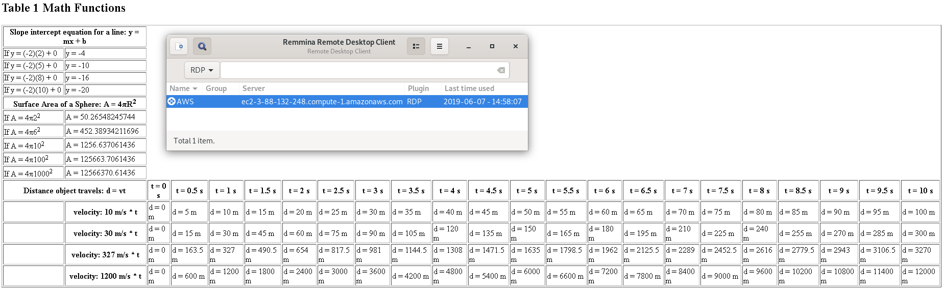

Zoomed In Shot of Second Table
